ONLINE SALES ANALYSIS
1. Project Overview
This project focuses on analyzing an online sales dataset to understand business performance, customer behaviour, and revenue trends. The analysis helps identify top-performing products, regions, and categories using data analytics techniques.
2. Dataset Summary
- Dataset Name: online_sales.csv
- Number of Rows: 10,000 (each row represents one sales transaction)
- Number of Columns: 9
Column Names and Description:
- transaction_id – Unique identifier for each transaction
- date – Date when the transaction occurred
- product_category – Category of the product sold
- product_name – Name of the product
- units_sold – Number of units sold in the transaction
- unit_price – Price of a single unit
- total_revenue – Total revenue generated from the transaction
- region – Geographic region where the sale occurred
- payment_method – Mode of payment used by the customer
3. Exploratory Data Analysis (EDA) Using Python
We began with data preparation and cleaning in python:
- Data Loading: Import the dataset using pandas.
- Initial Exploration: Used df.info () to check structure and describe () for summary statistics.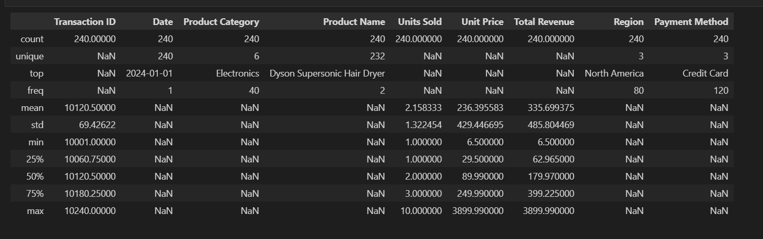
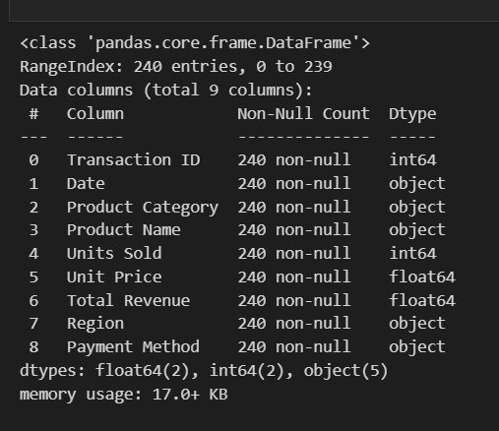

- Missing Data Handling: Checked for null values
- Column Standardization: Renamed columns to snake case for better readability and documentation.
- Feature Engineering: Checked payment analysis, revenue by region, revenue by category, checks column data type.
4. Data Analysis Using SQL
We performed structured analysis in SQL server to answer key business Question:
- Business Revenue: Total revenue generated by the business
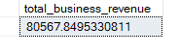
- Category Contribution: Revenue contribution by each product category
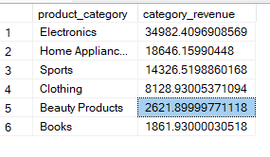
- Top-Selling Products: Products with the highest units sold
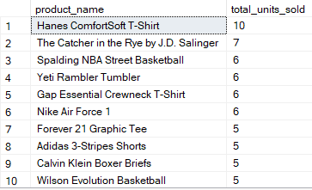
- Regional Performance: Sales performance across different regions
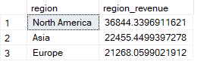
- Monthly Revenue Trend: Changes in revenue over time on a monthly basis
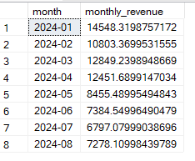
- Payment Preference: Most preferred payment method by customers
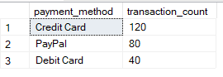
- Average Transaction Value: Average amount spent per customer transaction
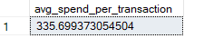
- Category Demand: Product category with the highest customer demand
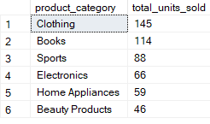
- Regional Spending Pattern: Regions where customers spend more per order
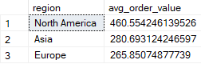
- Category-wise Top Products: Best-performing products within each category
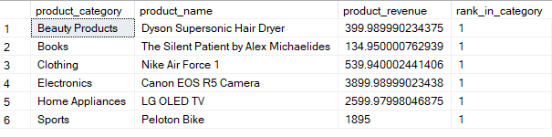
5. Dashboard in Power BI

